Pavan Chaitanya Business Analytics Assignment – Setting Up R

2022-09-24

# This Assignment helps in Analyzing the role of descriptive statistics in data exploration phase of analytics projects.

#Install the ISLR library using the install.packages() command.  
 #install.packages("ISLR")  
 #As this ISLR package is already installed it will not show an error that the package is already installed.  
  
  
#Calling the ISLR library using the library(ISLR) command to ensure that the library is correctly installed.  
library(ISLR)  
  
#Viewing the data set file Carseats that is present in the ISLR Library.  
 View(Carseats)  
  
#print the summary of the Carseats dataset  
 summary(Carseats)

## Sales CompPrice Income Advertising   
## Min. : 0.000 Min. : 77 Min. : 21.00 Min. : 0.000   
## 1st Qu.: 5.390 1st Qu.:115 1st Qu.: 42.75 1st Qu.: 0.000   
## Median : 7.490 Median :125 Median : 69.00 Median : 5.000   
## Mean : 7.496 Mean :125 Mean : 68.66 Mean : 6.635   
## 3rd Qu.: 9.320 3rd Qu.:135 3rd Qu.: 91.00 3rd Qu.:12.000   
## Max. :16.270 Max. :175 Max. :120.00 Max. :29.000   
## Population Price ShelveLoc Age Education   
## Min. : 10.0 Min. : 24.0 Bad : 96 Min. :25.00 Min. :10.0   
## 1st Qu.:139.0 1st Qu.:100.0 Good : 85 1st Qu.:39.75 1st Qu.:12.0   
## Median :272.0 Median :117.0 Medium:219 Median :54.50 Median :14.0   
## Mean :264.8 Mean :115.8 Mean :53.32 Mean :13.9   
## 3rd Qu.:398.5 3rd Qu.:131.0 3rd Qu.:66.00 3rd Qu.:16.0   
## Max. :509.0 Max. :191.0 Max. :80.00 Max. :18.0   
## Urban US   
## No :118 No :142   
## Yes:282 Yes:258   
##   
##   
##   
##

#Printing the maximum value of the advertising attribute that is present in Carseats datset.  
 max(Carseats$Advertising)

## [1] 29

#Calculating the InterQuartileRange(Upper Range-Lower range) of the Price attribute  
 IQR(Carseats$Price)

## [1] 31

#Plotting and calculating the correlation between sales VS Price  
#plotting the Sales against Price  
plot(Carseats$Sales,Carseats$Price,main = "Ploting the Sales against Price",xlab = "Sales",ylab = "Price")

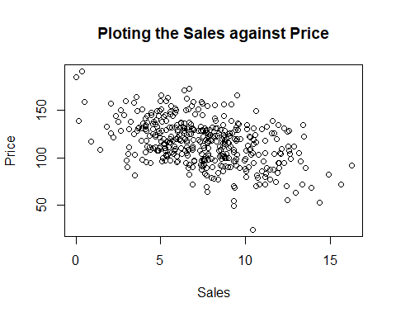

# Answer: I see that the points scattered   
   
 # Calculating the correlation of the two attributes(sales vS Price).  
cor.test(Carseats$Sales, Carseats$Price, method = c("pearson"))

##   
## Pearson's product-moment correlation  
##   
## data: Carseats$Sales and Carseats$Price  
## t = -9.912, df = 398, p-value < 2.2e-16  
## alternative hypothesis: true correlation is not equal to 0  
## 95 percent confidence interval:  
## -0.5203026 -0.3627240  
## sample estimates:  
## cor   
## -0.4449507

# There is a negative sign of the correlation coefficient. It suggests that the when one variable increases ,other variable decreases.  
 #ie when -> Sales increases Price decreases.   
 # Price increases Sales decreases.